Question Paper (Mathematics)-2023-24

Time: 3 hours Class-9th Total Marks:80
- Questions 1 to 3 in Part-A.
- Question 1 consists of 16 multiple-choice questions carrying 1 mark each.
- Question 2 contains 7 fill-in-the-blank questions carrying 1 mark each.
- Question 3 has 7 questions carrying 1 mark each with true/false answers.
- Questions 4 to 7 in Part-B carry 2 marks.
- Questions 8 to 13 in Part-C carry 4 marks. There is an internal exemption in any three questions in these questions. The exempted section of question 12 is the case study.
- Questions 14 to 16 in Part-C carry 6 marks, all these questions have internal exemption.
Part-A
1. Choose the correct option for the following questions. Each question carries 1 mark.
(i) Which of the following numbers is not a rational number?
(a) $\sqrt{4}$ (b) $\sqrt{2 }$ (c) 2 (d) $\sqrt{ 16 }$

(ii) The value of ${64}^{\frac{1}{2}}$
(a) $4$ (b) $6$ (c) 8 (d) 16
(iii) What is the coefficient of x in the polynomial x² - 2x + 3?
(a) 2 (b) -2 (c) –x (d) x
(iv) What are the coordinates of a point on the x-axis?
(a) (x, 0) (b) (0, y) (c) (0, 0) (d) (2, 2)
(v) Which of the following is a solution of the equation x - y = 2?
(a) (0, 0) (b) (- 2, 0) (c) (-6,2) (d) (-2, -4)
(vi) Two distinct lines cannot have more than point in common
(a) 1 (b) 2 (c) 3 (d) infinite
(vii) If a ray stands on a line then the sum of the adjacent angles so formed is
(a) 100⁰ (b) 180⁰ (c) 90⁰ (d) 360⁰

(viii) By which congruence rule following triangles are congruent ?
(a) SAS (b) ASS (c) AAS (d) none
(ix) If △ABC $≅$△PQR then which of the following is not true:
(a) BC = PQ (b) AC = PR (c) QR = BC (d) AB = PQ

(x) Which of the following is not a Parallelogram?
(a)Rhombus (b) Square (c) Trapezium (d) Rectangle
(xi) Angles in the same segment of a circle are equal.
- half (b) double (c) triple (d) equal
(xii) Find the length of the third side of a triangle whose two sides are 10 cm and 12 cm and perimeter is 33 cm.
(a) 8 cm (b) 13 cm (c) 11 cm (d) 88 cm

(xiii) The volume of the cone
a) $\frac{2}{3}$πr²h (b) $\frac{2}{3}$πr³h (c) $\frac{1}{3}$πr²h (d) $\frac{1}{3}$πr³h
(xiv) The curved surface area of a hemisphere of radius ‘r’ is
(a) 2πr² (b) 4πr² (c) 3πr² (d) 5πr²

(xv) The class mark of the class interval 110-130 is:
(a) 110 (b) 115 (c) 120 (d) 130
(xvi) Class mark and class size of the class interval are 25 and 10 respectively then the class interval is
(a) 20 – 30 (b) 30 – 40 (c) 40 – 50 (d) 50 – 60

2. Fill in the blanks. Each question carries 1 mark.
(i) Decimal representation of $\frac{1}{5}$ is ………… .
(ii) The zero of p(x) = 2x – 7 is............ .
(iii) Solution of the equation 2x + 1 = x + 3 is…………..
(iv) The number of angles formed by a transversal with a pair of lines are…….. .
(v) If △ABC $≅$△PQR then $∠$B=………
(vi) A quadrilateral is a _________, if its opposite sides are equal.
(vii) The longest chord of a circle is a ________ of the circle.

3. Select the True / False answer for the given questions. Each question carries 1 mark.
(i) If we add two irrational numbers, the resulting number is always an irrational number.
(ii) The degree of the polynomial 3x+1 is 0.
(iii) Things which are three times of the same thing ar not equal to each other
(iv) If diagonals of a quadrilateral are equal and bisect each other at right angles, then it is a square.
(v) The sum of either pair of opposite angles of a cyclic quadrilateral is 180º.
(vi) The sides of a triangle are 3 cm , 4 cm and 5 cm. Its semi-perimeter is 8.
(vii) The perpendicular distance of the point P(3,4) from the y – axis is 4.

Part -B
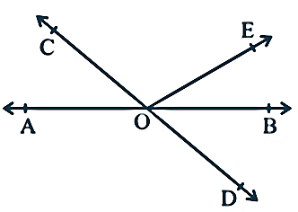
Each question carries 2 marks.
4.$W$rite $0.\overline{6}$in the form $\frac{p}{q}$ .
5. In Fig. , lines AB and CD intersect at O. If ∠ AOC + ∠ BOE = 70°
and ∠ BOD = 40°, find ∠ COE

6. Three angles of a quadrilateral are 75⁰, 90⁰ and 75⁰. Find the fourth angle.

7. Find the total surface area of a hemisphere of radius 10 cm.

Part-c
Each question carries 4 marks.
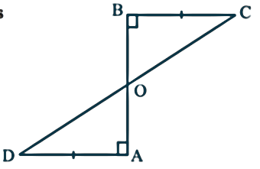
8. Write four solutions for equation 4x +3 y = 12.

9. AD and BC are equal perpendiculars to a line segment AB (see Fig.).
Show that CDbisects AB.
Or
Angles opposite to equal sides of an isosceles triangle are equal.
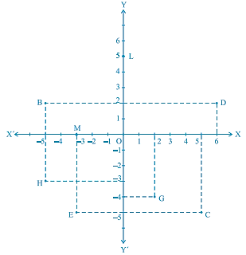
10. See Fig., and write the following:
(i) The coordinates of B
(ii) The coordinates of C
- The point identified by the coordinates (–3, –5).
- The point identified by the coordinates (2, – 4).
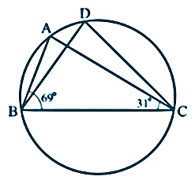
11. In Fig. , ∠ ABC = 69°, ∠ ACB = 31°, find ∠ BDC.

12. Sides of a triangle are in the ratio of 12 : 17 : 25 and its perimeter is 540cm. Find its area.
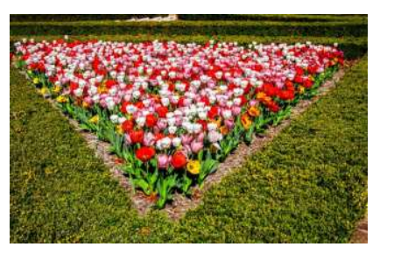
Or

The sides of a rectangular park are 80 m and 90 m respectively.
A small triangular area of side 8m, 10m and 6m respectively is
to be left out at the four corners of the park for growing flowering
plants. The remaining area is be planted with natural grass.
(a)What is the semi-perimeter of the triangle for the above measurements?
(b) Find the area used for growing flowering plants.

13.If the volume of a right circular cone of height 9 cm is 48 π cm³, find the diameter of its base.
Or

The diameter of a metallic ball is 4.2 cm. What is the mass of the ball, if the density of the metal is 8.9 g per cm³?

Part-D
Each question carries 6 marks.
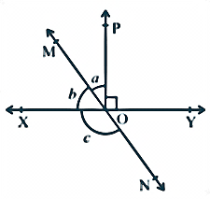
14. In Fig. , lines XY and MN intersect at O.
If ∠ POY = 90° and a : b = 2 : 3, find c

Or

Prove that if two lines intersect each other, then the vertically opposite angles are equal.

15. The length of 40 leaves of a plant are measured correct to one millimetre, and the obtained data is represented in the following table. Draw a histogram to represent the given data
Length (in mm) | Number of leaves
118 - 126 | 3
127 - 135 | 5
136 - 144 | 9
145 - 153 | 12
154 - 162 | 5
163 - 171 | 4
172 - 180 | 2

Or

In a city, the weekly observations made in a study on the cost of living index are given in the following table . Draw a frequency polygon for the data above.
Cost of living index | Number of weeks
140-150 | 5
150-160 | 10
160-170 | 20
170-180 | 9
180-190 | 6
190-200 | 2
Total | 52

16. Factorize 8x³ + 27y³ + 36x²y + 54xy².
Or
Find the value of (998)³ using the correct identity.

